Soccer/Futbol

One-sentence description:

Business opportunity or goal

Why its important

What data is being used

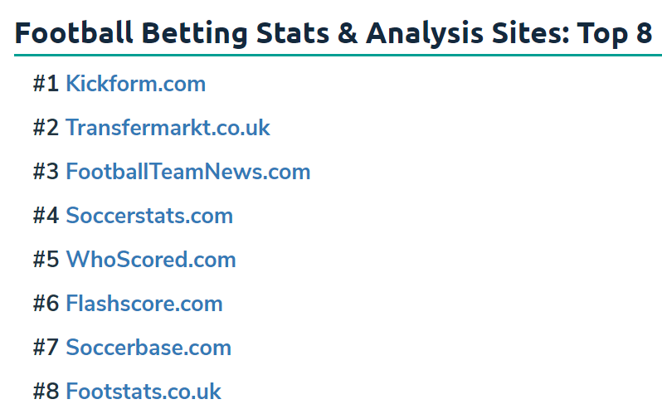

Explain the extract, transform, and load process

Who are the clients/customers

Carson Lenfestey, Pranjali Pingale, Soumyadeep Ray, and Jason Sigrist